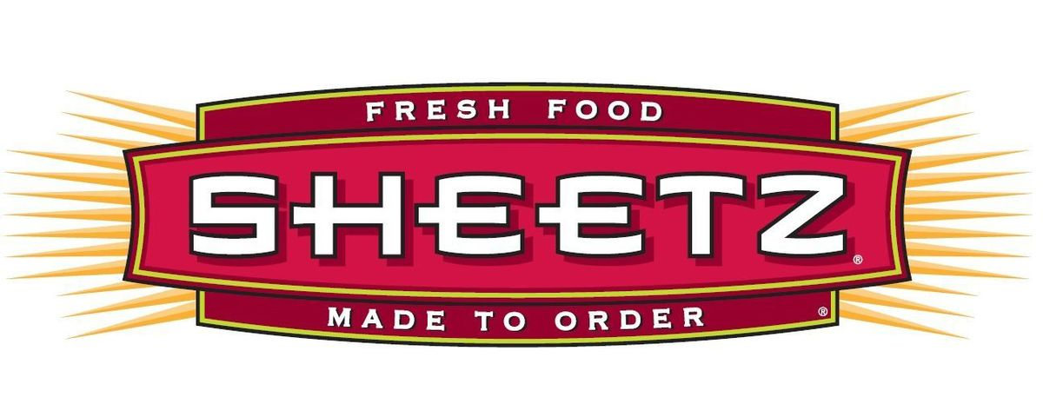
Sheetz Request for Commissioned Artists
Paid Proposal (RFP)

Project Summary

Sheetz, one of the nation’s largest and most successful family owned and operated convenience stores, is on the hunt for talented artists to showcase their unique skills on our carrier fleet. This effort is designed to take our fleet graphics to the next level and break the mold of traditional vehicle graphics. We’re searching for artists who can bring to life the edgy, fun and bold personality and uniqueness that is Sheetz, while featuring our logo and tagline: Sheetz Run & Done. The love for our brand is shared by Sheetz Freakz far and wide, and this is our opportunity to share the love with others on this highly visible touch point.

If this sounds like something you may be interested in, here is your chance to show us what you got!

About Sheetz
For more than 60 years, Sheetz has been the ultimate one stop shop for on-the-go consumers throughout the eastern part of the United States. It’s been our focus to offer the best of a restaurant combined with the best of a convenience under one roof saving valuable time and exceeding expectations for quality.

Design Criteria

BASIC GUIDELINES
- Sheetz logo should be included, though can be slightly altered to fit custom design
- Sheetz tagline, SHEETZ RUN & DONE, should be included
- Sheetz Red should be a leading color in design

Artist Eligibility

THE FOLLOWING REQUIREMENTS MUST BE MET
- Artist must be a fan of Sheetz
- Artist must have a home in the Sheetz footprint state that he or she is choosing to represent
- Both professionals and students may apply
- Artist teams may apply; however, a team will be paid the same as an individual (must split any potential winnings)

Application Requirements

ROUND 1 SUBMISSIONS MUST INCLUDE
- Link to the artist’s portfolio
- Sketch or idea write-up (this is optional and unpaid)

Selection Criteria
One final artist from each state in the Sheetz footprint will be selected upon their ability to communicate the Sheetz Brand in a new and bold way. Using the artists personal style and a Sheetz Freak level of love for the brand, the final design should interpret the Sheetz brand in a unique, fresh, and a dynamic way. Additionally, the final design must include the tagline “Run & Done.”

Commission/Budget

POTENTIAL PAY-OUT/WINNINGS
- ROUND 1: to be considered you must initially share a link to your portfolio, and you may submit an optional sketch for consideration—any sketch submitted during application phase will be unpaid. Additionally, a statement of interest in the opportunity can help your cause.
- ROUND 2: five (5) artists from each state will be selected to submit art to be judged—these artists will each receive $1,500 for original sketch
- ROUND 3: one (1) artist from each state will be chosen and paid $25,000 for their final works of art, including three rounds of revisions

Project Timeline

Round 1: Selected Art Schools and Councils will participate in the RFP by sharing candidate’s requirements for Round 1.

Wednesday, May 30th - Final Due Date for all Artists participating in the RFP to share their first round of submissions, which includes sketches, link to portfolio and write-ups.

Friday, June 1st - Agency Tattoo Projects to select (5) artists per DMA

Round 2: Selected Artists have been chosen to submit art to be judged.

Sunday, July 1st - Selected Artists to share their second round of creative with Sheetz, Inc., and Tattoo Projects.

Round 3: (1) selected Artist per state will be chosen by Sheetz Inc., and Agency based on selects from round 2. Below is the timeline prepared for our selected artists per state.

- Monday, July 2nd - Round 1 feedback due from Sheetz, Inc., and Tattoo Projects
- Thursday, July 12th - Round 1 Revised Artwork Due by Artist
- Monday, July 16th - Round 2 Feedback/approvals Due from Sheetz, Inc., and Tattoo Projects
- Monday, July 23rd - 2nd Round of Revisions Due by Artist
- Wednesday, July 25th - Round 3 Feedback/approvals Due from Sheetz, Inc., and Tattoo Projects
- Tuesday, August 7th - 3rd Round of Revisions Due by Artist
- Friday, August 10th - Final Art Chosen by Sheetz, Inc., and Tattoo Projects
- Wednesday, August 15th - Final Printer Ready Files Due by Artist

Submission URL

sheetzfleetcompetition@gmail.com

Resources for Questions
If you have any further questions, please feel free to reach out to sheetzfleetcompetition@gmail.com

Addendum
Tractor Trailers/Gas Tankers Description

TRAILERS
Sides: Actual Size: 625” x 100”, Bleed Size: 629” x 104”

TRAILER REARS
Rear Live – 96” x 107” high (Note – there are both Great Dane and Utility Rears that have different obstructions)
Canvas Size – 100” x 111”

GAS TANKERS
Sides: Actual Size: 498—505” x 58”, Bleed Size: 511” x 60” (note – visual centerline on tank is 22” from the bottom. Also, the top 10” is not very well seen so keep key elements below.)

GAS TANKER REARS
Rear Actual Size: 92” x 66”, Bleed Size: 94” x 69” (refer to Photoshop file “Tanker Rear Template.psd”)

*Please view below previous artwork images of tractor trailers and gas tankers.

Tanker Sides
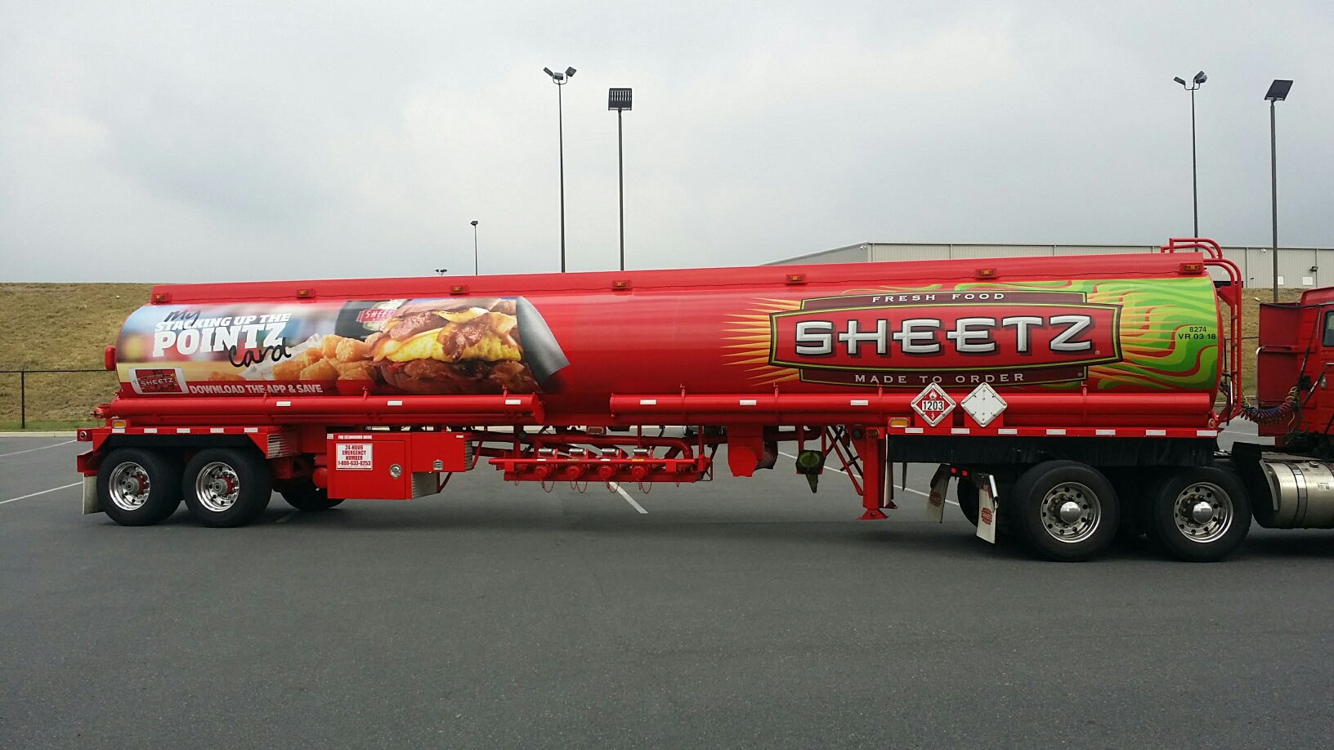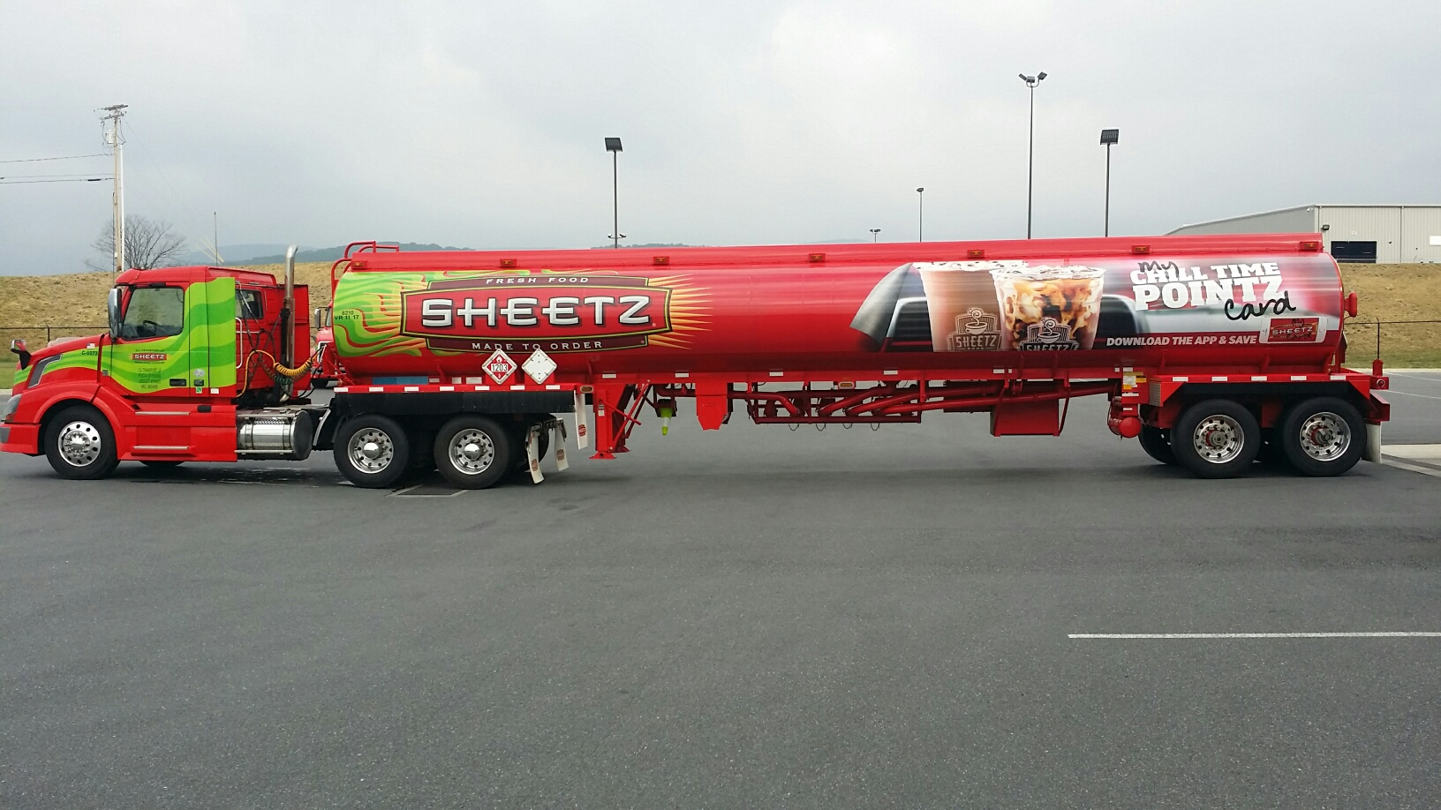

Tanker Rear
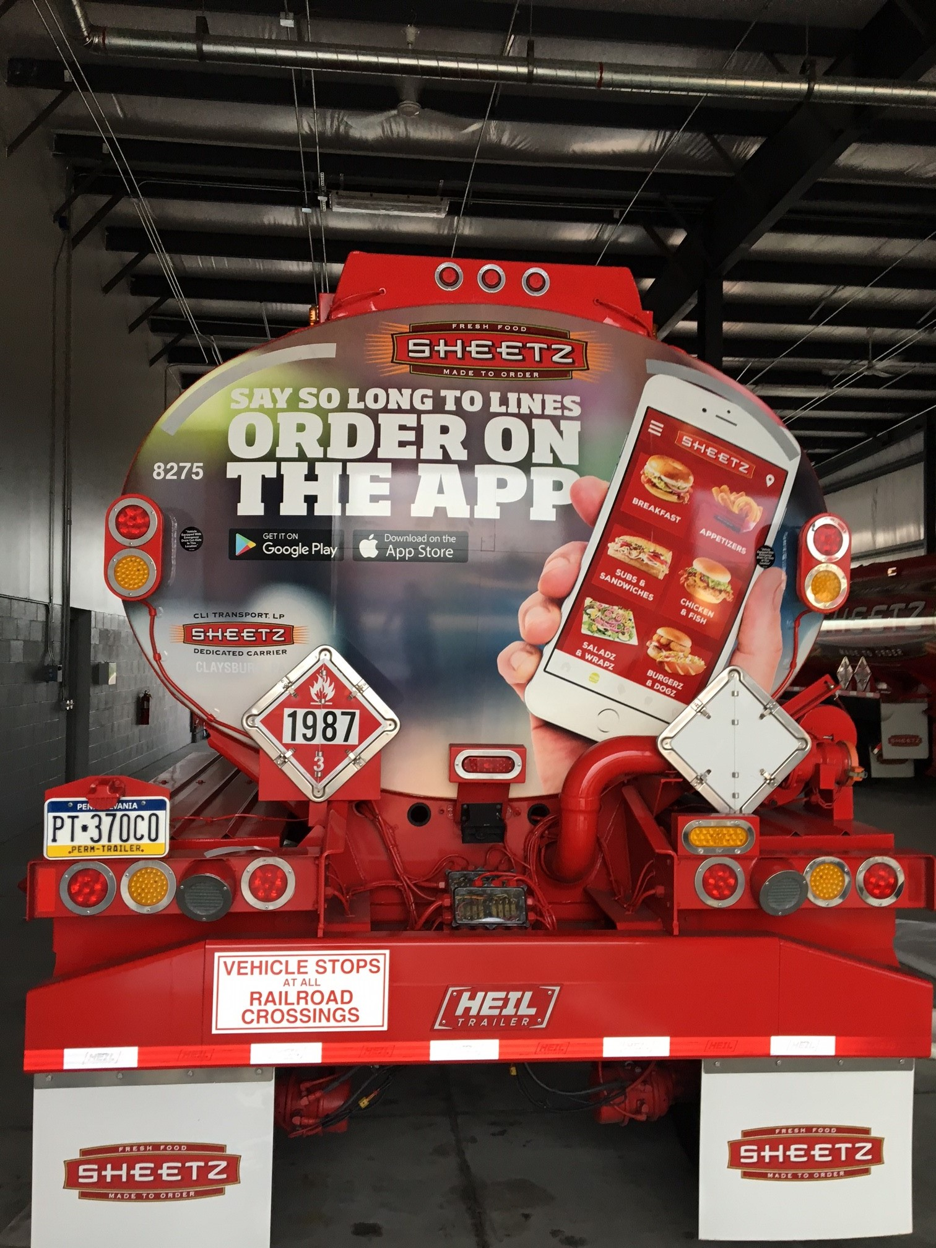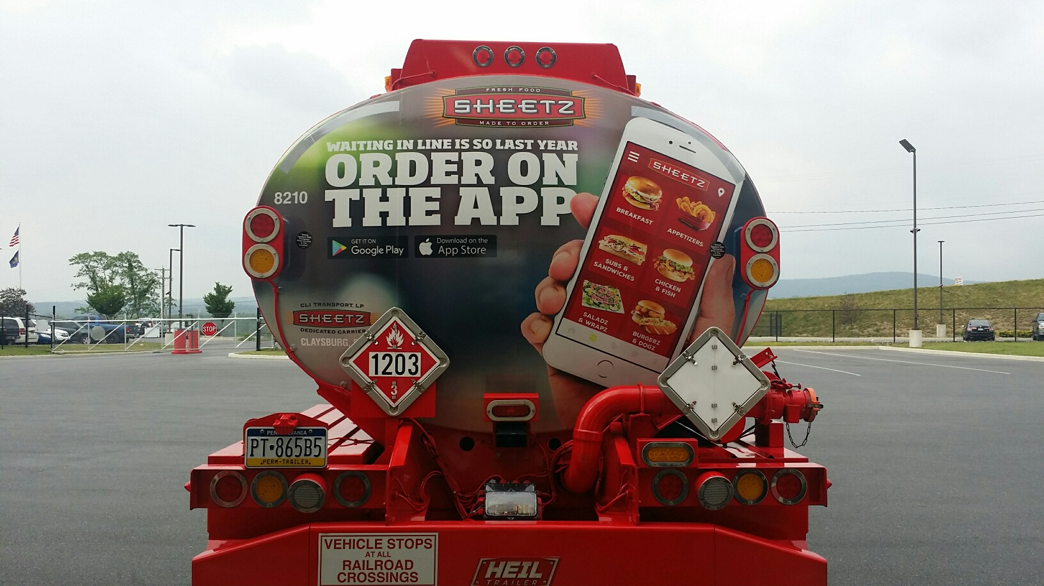
Tanker Sides
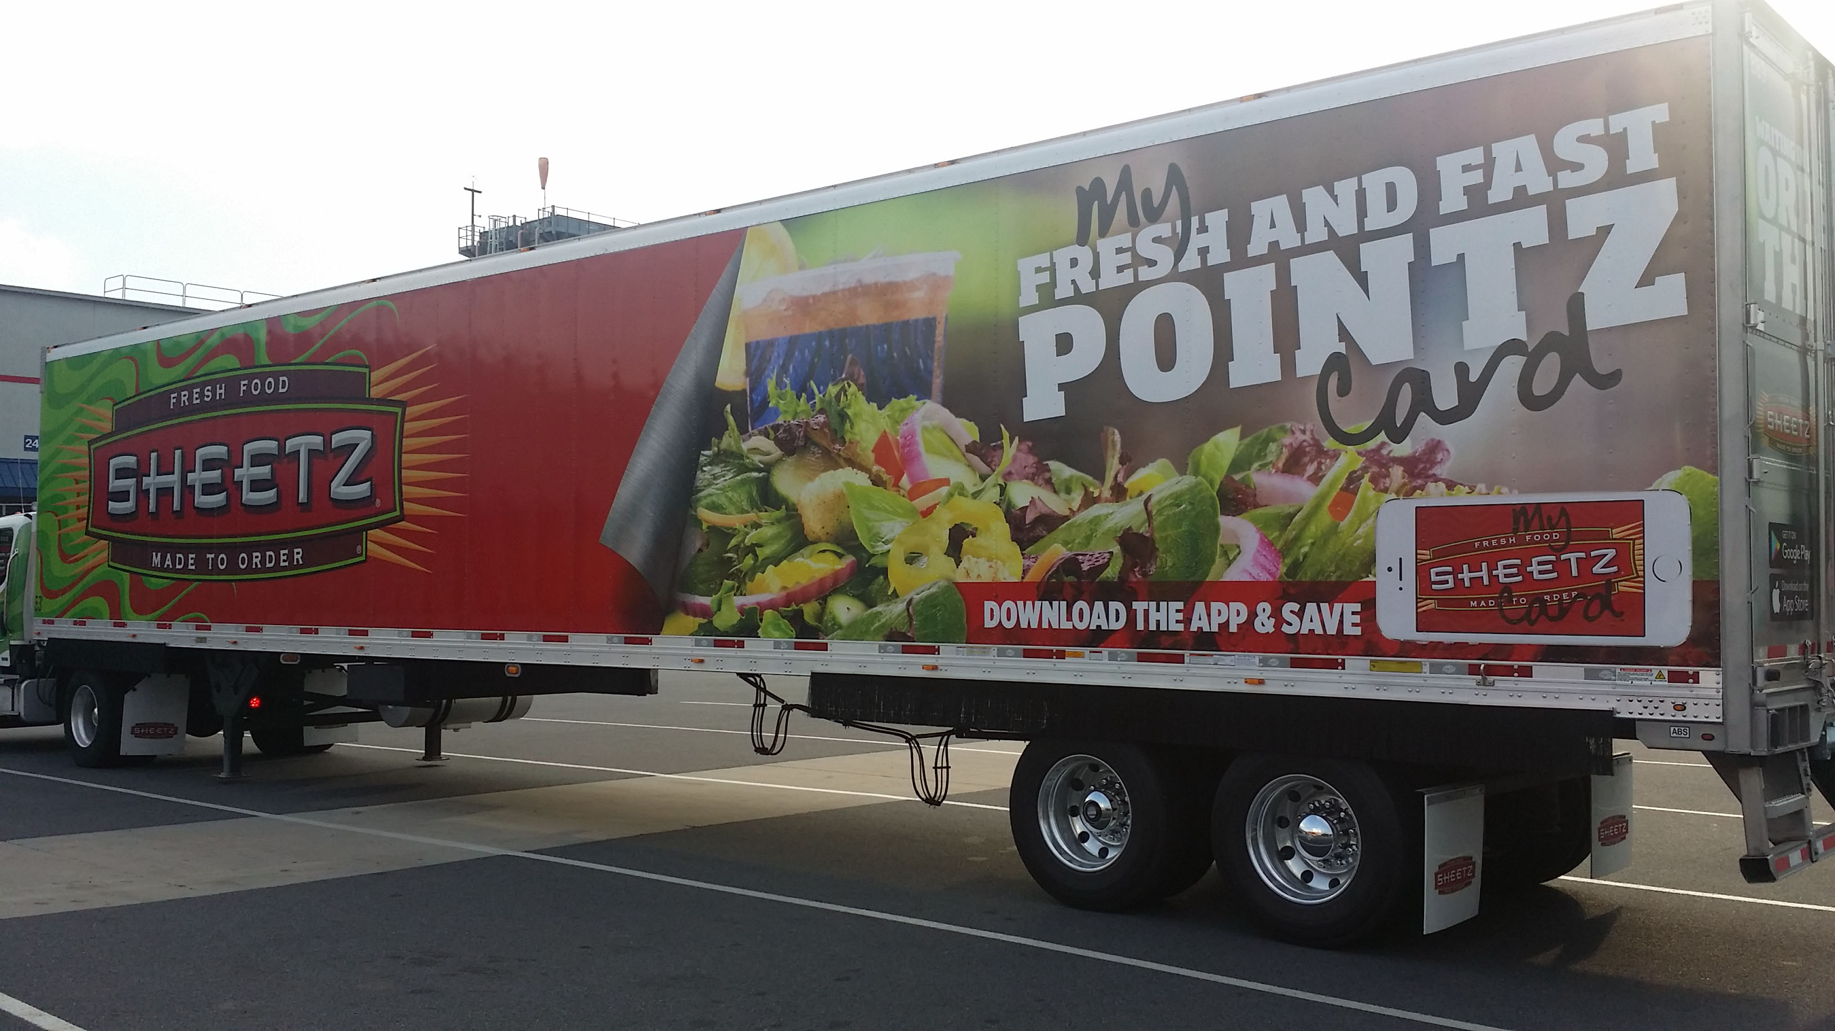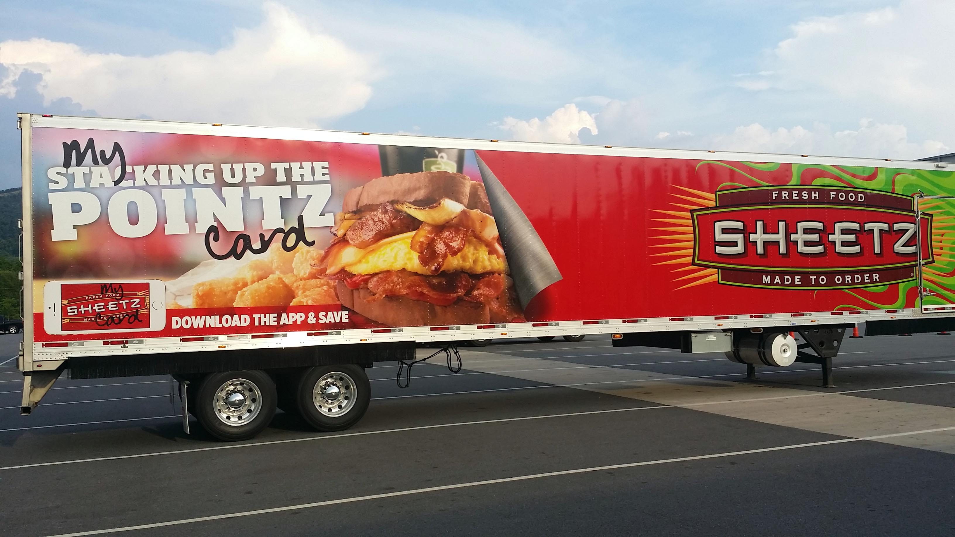

Tanker Rear
