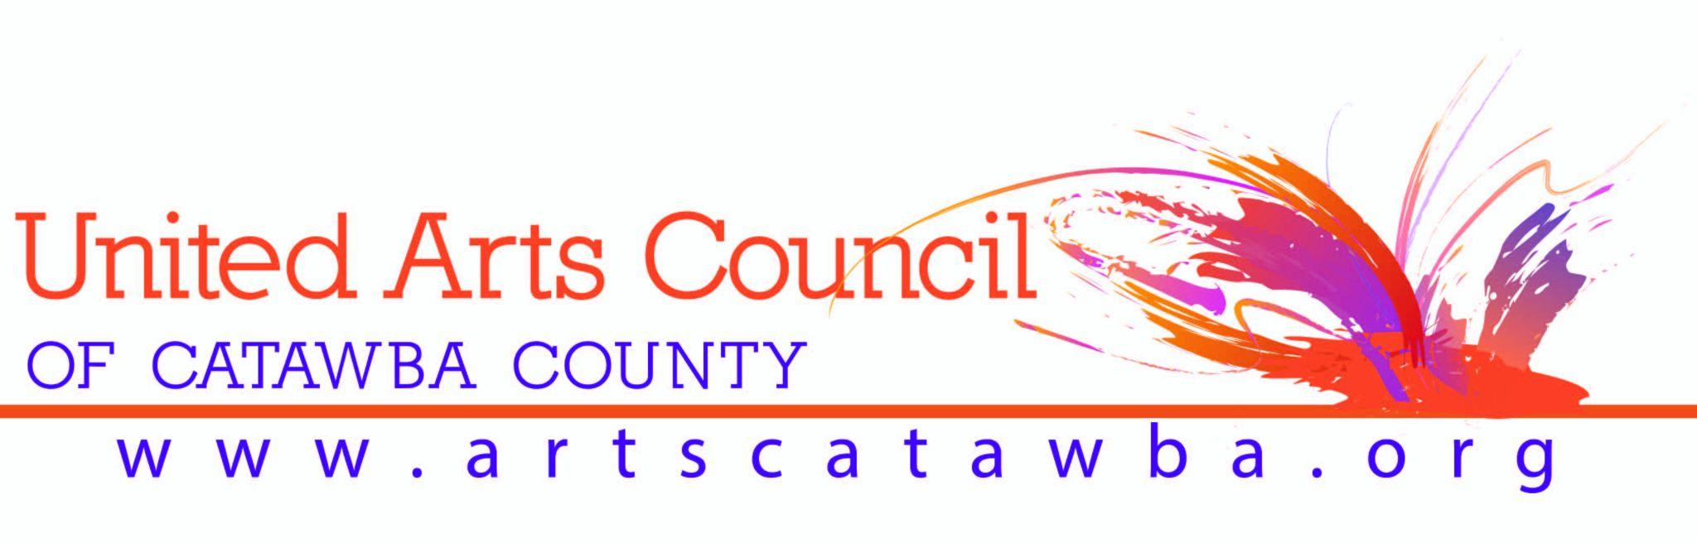
UNITED ARTS COUNCIL OF CATAWBA COUNTY
ACKNOWLEDGMENT WORDING FOR GRANT AWARDS

UNITED ARTS FUND

Funded Affiliates shall promote UAC and the UAF. Funded Affiliates shall acknowledge United Arts Funding in printed materials, including general brochures, membership brochures, programs, press releases and letterhead with the words “Funded Affiliate of the United Arts Council.” The “United Arts Fund” shall be listed in all Funded Affiliate donor publications at the appropriate donor level. The United Arts Fund shall be promoted publicly at all events of Funded Affiliates. The UAC’s logo shall be utilized whenever appropriate.

PROJECTS POOL

“This project was supported by the United Arts Council of Catawba County through the North Carolina Arts Council, a division of the Department of Natural and Cultural Resources, with funding from the State of North Carolina from the National Endowment for the Arts.” If you list donor participation in printed materials or on your website you must include the “United Arts Council of Catawba County” and the “North Carolina Arts Council” in the appropriate category. (Use NC Arts Council logo and United Arts Council of Catawba County logo with printed materials.)

INNOVATIVE ARTIST GRANT

“This project is supported by a grant from the United Arts Council of Catawba County” in all printed material and publicity.

COMMUNITY CULTURAL FUND GRANT

“This project is supported by a grant from the United Arts Council of Catawba County” should be stated in all printed material and publicity. Please hang a banner acknowledging the Arts Council at your event. The banner is available in the Arts Council office by contacting Marketing Assistant Pam Walters, phone and email below.

COLLABORATIVE ARTS GRANT (CAP)

“This project is supported by a grant from the United Arts Council of Catawba County” should be stated in all printed material and publicity. If appropriate, please hang a banner acknowledging the Arts Council at your event. The banner is available in the Arts Council office by contacting Marketing Assistant Pam Walters, phone and email below.

THEATRE ARTS GRANT (TAG)

“This project is supported by a grant from the United Arts Council of Catawba County” should be stated in all printed material and publicity. At your production, please hang a banner acknowledging the Arts Council at your production. The banner is available in the Arts Council office by contacting Marketing Assistant Pam Walters, phone and email below.

United Arts Council Logos are available from Pam Walters, Marketing Assistant, 828-324-4906 x 307 pwalters@artscatawba.org or on our website www.artscatawba.org/about-us

